



RMI Snake Game Project Report


Course: IN441 Distributed Systems

Student Name: Fatima Naddah

File Number: 31173
Source Code : https://github.com/Fatima-bit80/RMI-snake-game







1-Contents:
- Game Overview
- GamePlay Overview
- System Architecture
- Remote Interfaces
- RMI Implementation
- Concurrency & Race Condition Prevention
- Swing Thread Safety (EDT)
- Real-Time Game Implementation
- Non-Blocking Notifications
- Collision Detection
- Fruit Mechanics
- Late-Join Support


2-Game Overview:

This project is a real-time multiplayer Snake game built in Java using RMI.

Players connect to a central server over a local network, join a shared lobby, and play simultaneously on the same game board.

The project demonstrates how RMI can be used to coordinate a live, multi-player interactive application with concurrent game state management.

All communication between clients and the server happens through RMI remote calls, with the server pushing updates to each client in real time using separate threads.

3-GamePlay Overview:

●Players enter their name and server’s ip address to connect

●Players can chat in the lobby before the game starts

●When all players are ready, the game starts

●Snakes can move by pressing WASD keys

●The goal is to become the biggest snake alive.

●Snakes grow by eating food and die by either colliding with themselves, other snakes or the game border.

Screenshots:

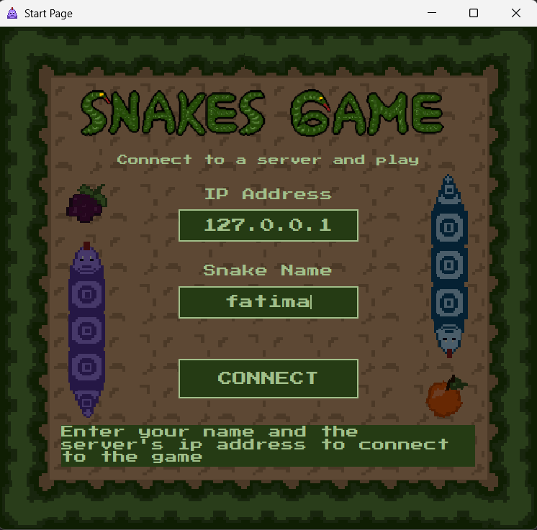
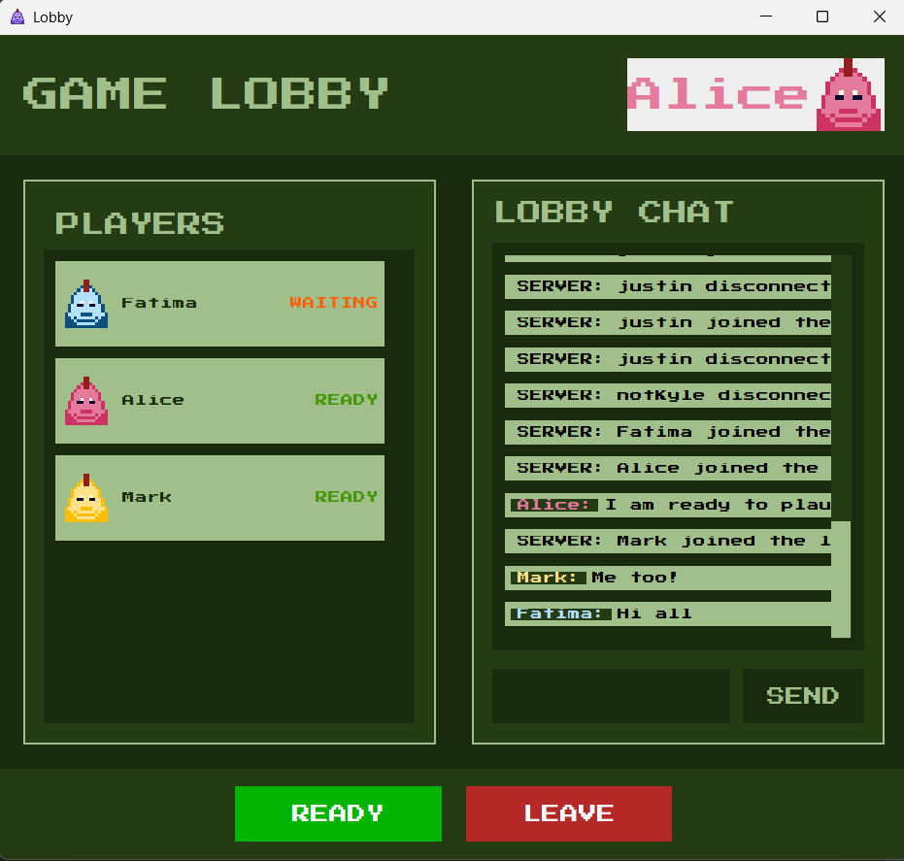

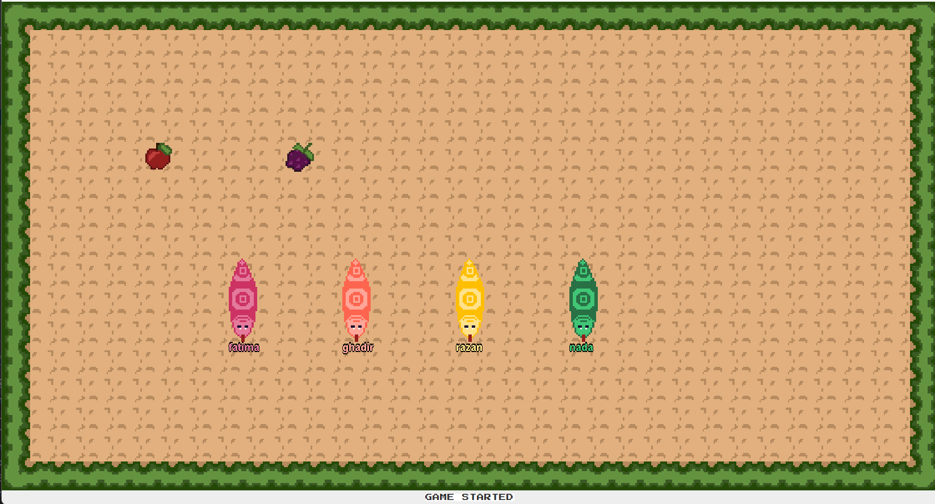

4-System Architecture

The project follows a client-server architecture.
The server exposes a remote interface (ISnakeServer) that clients call to perform actions.
The server in turn holds references to each connected client through the ISnakeClient remote interface, allowing it to push updates back to clients.

5-Remote Interfaces

ISnakeServer (Server-side interface, called by clients)
Method | Purpose
connect(client, name) | Player joins, receives an assigned integer ID
requestStartGame(id) | Player signals ready; game starts when all are ready
setDirection(id, direction) | Server updates the snake's movement direction
displayLobbyChat(id, text) | Broadcasts a chat message to all lobby players
disconnect(id) | Cleanly removes a player from the lobby or game

ISnakeClient (Client-side interface, called by server to push updates)
Method | Purpose
addToLobby(...) | Server sends full lobby state when player joins
addASnakeToLobby(snake) | Notifies existing players of a new arrival
updateASnakeInLobby(snake) | Pushes ready-status or color change to all clients
ASnakeDisconnected(snake) | Tells clients to remove a player from the UI
startGame(snakes, fruits) | Tells the client to switch to the game screen
updateGame(snakes, fruits) | Sends full game state each tick
displayMessage(message) | Delivers a lobby chat or server message
die() | Notifies a player that they have been eliminated

6-RMI Implementation

RMI is the foundation of all networking in this project.
Both the server and the clients expose remote objects, the server through ISnakeServer and each client through ISnakeClient.
This bidirectional design allows the server to push game state to clients without any polling (notifications).

Notifications:

Rather than having clients poll for updates, the server holds a map of ISnakeClient references and calls methods on them directly. For example, to notify all players of a new arrival:

for (int i : players.keySet()) {
ISnakeClient c = players.get(i);
c.addASnakeToLobby(s);
c.displayMessage(lobbyMessage);
}

The same pattern is used for game updates, disconnect notifications, and game-over signals.
This is the core of the real-time experience, the server drives all state changes.

7-Concurrency & Race Condition Prevention

Because multiple players connect and act simultaneously, thread safety is critical.
The server handles concurrent access through a combination of synchronized methods, thread-safe collections, and careful snapshot iteration.

8-Swing Thread Safety (EDT)

On the client side, all GUI updates are dispatched through SwingUtilities.invokeLater().

RMI callbacks arrive on a pool thread, not the Event Dispatch Thread (EDT). Wrapping every UI update in invokeLater() prevents Swing race conditions:
SwingUtilities.invokeLater(() -> {
mainFrame.getLobbyPanel().addPlayer(s);
});

9-Real-Time Game Implementation

The real-time feel of the game comes from the server running a continuous game loop on its own thread, and notifying every player of state changes using separate threads per notification, so the loop never waits for a slow or unresponsive client.

Example:

Once all players are ready, startGame() is launched on a dedicated thread:

new Thread(() -> {startGame(); }).start();
10-Non-Blocking Notifications (Thread Per Client)

Notifying clients is done in parallel, each client gets its own thread.
This is essential: a single slow or unresponsive client must not freeze the game loop for everyone else:

public void notifyNewSnakePositions() {
for (int i : new ArrayList<>(players.keySet())) {
new Thread(() -> {
ISnakeClient c = players.get(i);
if (c != null) c.updateGame(snakes, fruits);
}).start();
}
}

The same approach is used in notifyAllPlayersGameStarted() when the game first begins, so no player waits for another to receive their start signal.

11-Collision Detection

The server maintains a 2D boolean grid (positions[COLUMNS][ROWS]) representing occupied tiles.
After every move, the grid is rebuilt from the current snake coordinates.

A snake dies if its new head position:

Hits the border (x <= 0, x >= COLUMNS-1, y <= 0, y >= ROWS-1), or
Lands on an already-occupied tile (positions[x][y] == true — any snake's body).

Elimination is handled in a new thread, disconnecting the player and calling die() on their client, again without blocking the main game loop.

12-Fruit Mechanics

Two fruits exist on the board at all times (stored in the fruits ConcurrentHashMap with keys 0 and 1).
When a snake eats a fruit, the fruit is removed and a new one is placed at a randomly selected free tile via the synchronized findCoordinate() method.
The snake grows by one tile , a new head coordinate is prepended to its coordinate list without removing the tail.

13-Late-Join Support

A player who joins after a game has already started is handled by addToOnGame().

The server immediately sends them a startGame() call with the current snake and fruit state, so they enter the live game without waiting for a new round.

